Smart Surveillance and Violence Detection System

# Sanchit Patil

*Dept. of Electronics and Telecommunication Sardar Patel Institute of Technology* Mumbai, India

E-mail: [sanchit.patil@spit.ac.in](mailto:sanchit.patil@spit.ac.in)

# Sridhar Sundar

*Dept. of Electronics and Telecommunication Sardar Patel Institute of Technology* Mumbai, India

E-mail: [sridhar.a@spit.ac.in](mailto:sridhar.a@spit.ac.in)

# Ankit Prasad

*Dept. of Electronics and Telecommunication Sardar Patel Institute of Technology* Mumbai, India

E-mail: [ankit.prasad@spit.ac.in](mailto:ankit.prasad@spit.ac.in)

# Dr. Sukanya Kulkarni

*Dept. of Electronics and Telecommunication Sardar Patel Institute of Technology* Mumbai, India

E-mail: [sukanya_kulkarni@spit.ac.in](mailto:sukanya_kulkarni@spit.ac.in)

***Abstract*—The continuous monitoring of surveillance camera feeds presents significant challenges in terms of time, energy, and resource management. The traditional approach of maintaining constant vigilance across multiple cameras is both labor-intensive and inefficient, leading to excessive processing power consumption and storage demands. This paper proposes an automated motion detection system designed to optimize surveillance operations by activating cameras only when motion is detected within their field of view. By integrating motion sensors with a camera management protocol, the system ensures that cameras are operational only when necessary, thereby reducing unnecessary energy expenditure and conserving storage resources. This approach not only enhances the efficiency of surveillance operations but also addresses the limitations associated with the manual monitoring of extensive camera networks. The effectiveness of the proposed system is evaluated through simulation and real-world testing, demonstrating its potential to significantly improve surveillance efficiency and resource management.**

***Index Terms*—Real time surveillance; Violence Detection, Activity Recognition, Object detection, Motion detection;**

1. INTRODUCTION

In contemporary urban environments, the proliferation of surveillance cameras has become a ubiquitous feature. While these cameras offer a valuable tool for security and monitoring, manually reviewing footage from numerous cameras is a time-consuming and error-prone task. To address these limitations, this research proposes a smart surveillance and abnormal activity detection system that leverages computer vision techniques to automatically identify and alert authorities to potential instances of violence or other anomalous behaviors.

By automating the process of surveillance, our system aims to reduce the reliance on human intervention, enhance the accuracy of detection, and provide timely alerts to control rooms. This will enable security personnel to prioritize their attention to areas where high-risk situations may be developing. To ensure comprehensive coverage, we have implemented a feature that automatically rotates cameras based on motion detection using a network of PIR sensors.

This system effectively detects motion from various directions and adjusts the camera's orientation accordingly.

To optimize resource utilization, we have incorporated a mechanism that automatically switches off cameras when no motion is detected. This feature helps conserve processing power, which is a critical consideration given the computationally intensive nature of computer vision algorithms. For real-time processing of computer vision models, our system employs an NVIDIA Jetson board, which is integrated with a Raspberry Pi camera module to capture surveillance footage. Additionally, a network of Raspberry Pi devices equipped with PIR sensors is used to detect motion and communicate with the Jetson board.

To facilitate remote monitoring and alerts, a web server is hosted on the Jetson board, allowing control rooms to access camera feeds and receive notifications. In cases of severe violence, an audible alarm is activated to alert individuals in the vicinity. By combining these innovative features, our proposed system offers a robust and efficient solution for enhancing security and public safety in various settings, including schools, colleges, offices, residential areas, and public spaces.

1. RELATED WORK

This review examines recent advancements and methodolo- gies proposed in academic literature for improving Smart Surveillance systems, violence detections and abnormal activity detections using various technologies. Four significant studies are analyzed, each contributing unique insights into enhancing the accuracy of the model and implementation of various features in the system. These studies span different approaches, including AI-based violence detection, abnormal activity detection and smart surveillances.

1. V. Mandalapu, L. Elluri, P. Vyas and N. Roy, "Crime Prediction Using Machine Learning and Deep Learning: A Systematic Review and Future Directions,"(2023): use of machine learning and deep learning techniques to predict crime. It analyzes over 150 articles, explores different

algorithms, and provides insights into crime patterns.The paper also highlights potential gaps and future directions for improving crime prediction accuracy.

[2] Amrutha C.V, C. Jyotsna, Amudha J., “Deep Learning Approach for Suspicious Activity Detection from Surveillance” (2020): Use of deep learning to detect suspicious activity inside college campuses, techniques like video surveillance, CNN, LSTM, RNN. Classifies frames into 3 category - students using mobiles, fighting/ fainting, Walking/ Running.

[3] Adupa Nithin Sai, Kowdodi Siva Prasad., “Machine Learning Software for the Detection of Violence from CCTV Footage” (2023): CNN and LSTM methodology in violence detection purpose, how data collection, data processing and feature extraction are pivotal for data handling and learnt about AI/ML, Database maintenance and report generation to headquarters, other methods like Transfer Learning, SVM, RNN.

[4] A. Jain, S. Basantwani, O. Kazi and Y. Bang, "Smart surveillance monitoring system," (*2017)*: The proposed smart surveillance system uses Raspberry Pi and PIR sensors to detect motion and activate cameras only when needed, reducing power and storage usage. It streams live video to devices via WAN/LAN and triggers alerts for suspicious activity using the ViBe algorithm. To ensure secure transmission of footage, Blowfish encryption is applied, protecting it from hackers.

These papers collectively contribute to the development of integrated systems that enhance motorcycle safety, promote helmet compliance, and ensure timely emergency assistance, significantly reducing the risks associated with motorcycle accidents.

1. PROCESS
2. *Proposed System*

The proposed system integrates several distinct units, each responsible for different critical tasks to ensure seamless operation and coordination. At the heart of this system is the microcontroller unit. Specifically, the ESP-32 Cam module is chosen as it is equipped with an onboard OV2640 camera, which allows it to capture high-resolution images efficiently. In parallel, the ignition control unit is designed to manage the ignition system of the motorcycle. This unit utilizes a relay circuit that controls the ignition based on the input it receives. The ESP-32 Cam module and ignition control circuit are depicted in Figure 1. Furthermore, a web server is built using technologies such as Node.js and Express.js to create an API endpoint to receive images from the motorcycle unit and performs helmet detection. Overall, this integrated system combines image acquisition, ignition control, and web-based communication.

* 1. **ESP-32 Cam Module:** The ESP-32 CAM module is equipped with a 2MP OV2640 camera, which supports an array size of 1600x1200 and is capable of capturing images at a maximum transfer rate of up to 60 fps. It is powered by a low-power 32-bit CPU with a clock speed of up to 160MHz, making it suitable for various image processing tasks in IoT applications. The module features built-in Wi-Fi (802.11 b/g/n) and Bluetooth 4.2 LE, allowing for seamless wireless communication and integration with IoT networks. Widely used in IoT appli- cations requiring image processing, the ESP32-CAM is designed with energy efficiency in mind, making it ideal for battery-powered or remote IoT devices where power consumption is a critical consideration.
  2. **Relay:** A relay is a mechanical switch that operates on the principle of electromagnetism. It enables the control of a high-power circuit using a low-power circuit, making it useful in various applications. The relay used operates on a 12V DC signal and has a current capacity of 40A, allowing it to handle high-power loads effectively (refer to Figure 1 for relay circuit setup).
  3. **Web Server:** The web server is built using Node.js, a popular JavaScript runtime environment known for its efficiency and scalability. Express.js is used alongside Node.js to simplify the process of building APIs, making it easier and faster to develop web applications. The APIs developed with Express.js are tested using tools like Postman, which allows for easy and effective API testing.
  4. **Google Cloud Vision:** GCP’s Vision AI is a service that enables developers to incorporate advanced image analy- sis capabilities into their applications. It offers a range of functionalities, including image labeling, face detection, landmark detection, and Optical Character Recognition (OCR). The service provides API endpoints, allowing for easy integration of these features into various appli- cations. Developers can utilize a Software Development Kit (SDK) for Node.js to interact with GCP’s Vision AI, streamlining the development process in JavaScript environments.

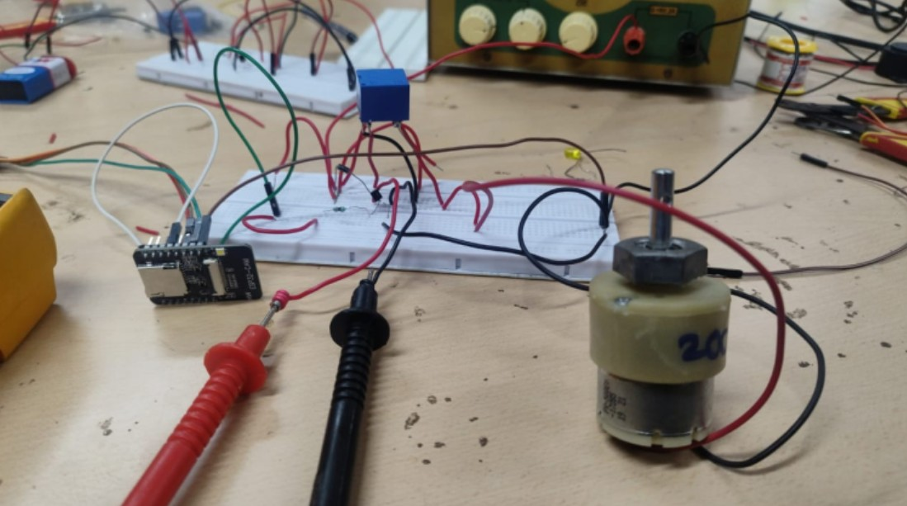

Figure 1. Hardware components and testing

1. *Methodology*

The core of the system is the ESP-32 CAM module, which serves as the central component for image acquisition, cap- turing real-time images of the rider to verify helmet presence. The entire architecture of the system is divided into three main functions: image acquisition, ignition control, and the web server. The image acquisition function processes the rider’s image, the ignition circuit interacts with the motorcycle’s electrical system to enable or disable the engine based on the helmet detection, and the web server provides an interface for monitoring and managing the system remotely, ensuring seamless communication between hardware and software com- ponents.

* 1. **Image acquisition:** The hardware setup involves con- necting the microcontroller to the motorcycle power supply, and it is programmed to continuously capture images of the rider using the onboard OV2640 camera. The algorithm begins by capturing initial images when the rider attempts to start the motorcycle. These captured images are then passed to an API endpoint implemented in the web server, which returns either True or False depending on the detection of a helmet (refer to figure 2 for the request/response cycle between the server and ESP-32 Cam module).
  2. **Ignition control:** The ignition control unit incorporates a relay circuit that acts as a switch between the low-power microcontroller system and the high-power motorcycle ignition system. A BC-548 transistor is used between the microcontroller and the relay, and a flywheel diode is placed in parallel with the relay. The control logic works as follows: when a helmet is detected, the output pin assigned on the microcontroller is turned high, which then goes to the base of the transistor. The voltage provided by the output pin is more than the cutoff voltage of BC- 548, causing the transistor to close like a switch. This allows current to flow from the collector to the emitter, completing the circuit. Consequently, the relay is turned on, and current starts flowing in the output circuit of the relay. The entire algorithm works according to the flowchart given in Figure 4.
  3. **Web server and communication:** A web server is established using Node.js and Express.js, responsible for receiving image data from the ESP-32 Cam module and performing the helmet detection task. Google Cloud Vision API service is used in the backend server for detection purposes, with GCP’s Node.js SDK utilized to interact with Google Cloud Platform. The GCP’s Vision API endpoint is called from the backend, and the response is an array of objects detected in the image. The logic in the API endpoint checks for the ’Helmet’ label in this array, and if the ’Helmet’ label is present, the API sends a True response to the microcontroller. The API response is shown in Figure 5. The API endpoints are built using REST (Representational State Transfer) architecture, with HTTP (Hypertext Transfer Protocol) as the underlying

protocol. For emergency messages, Twilio is used—a communication API service that provides SMS, voice, email, and other features. An API key is generated on the Twilio platform, which is used whenever their SMS API endpoint is called. An example of the SMS received is given in Figure 8.

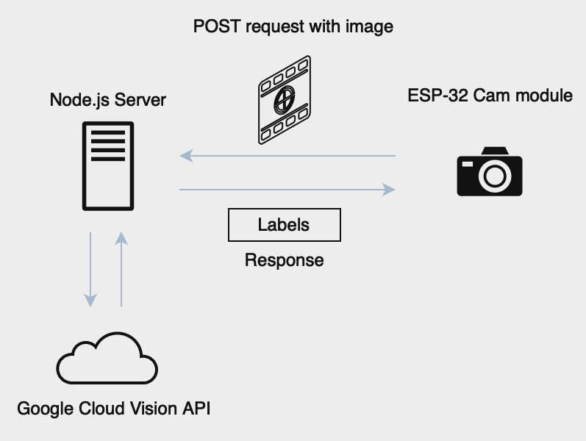

Figure 2. ESP-32 connection with the server

1. FLOWCHARTS

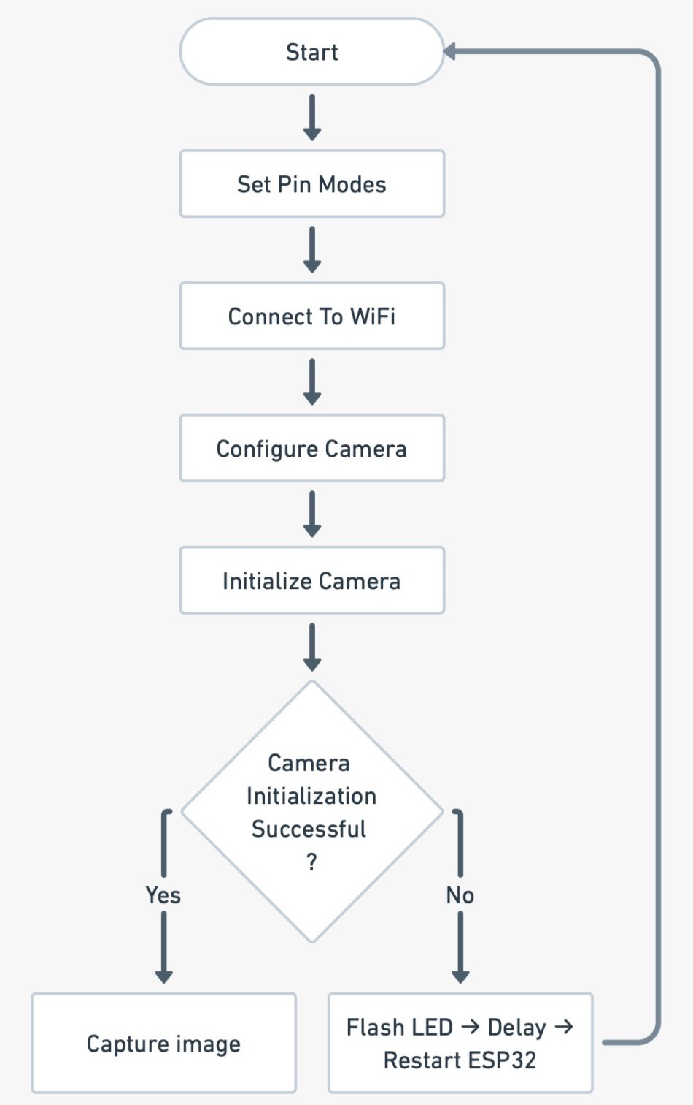

Figure 3. ESP-32 Cam module initialisation flowchart

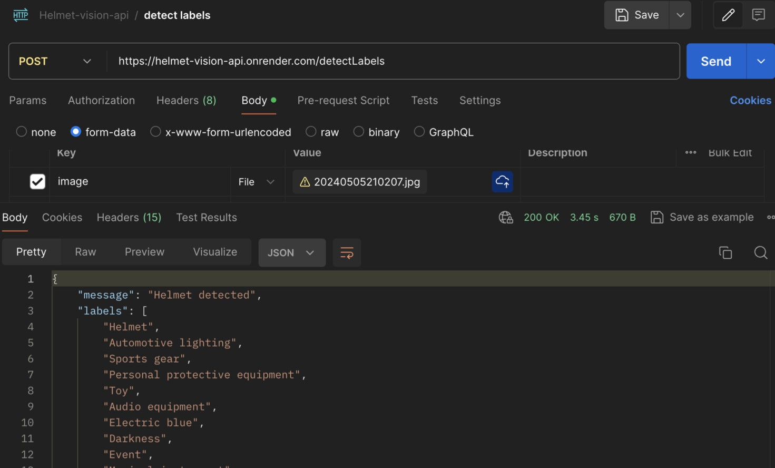

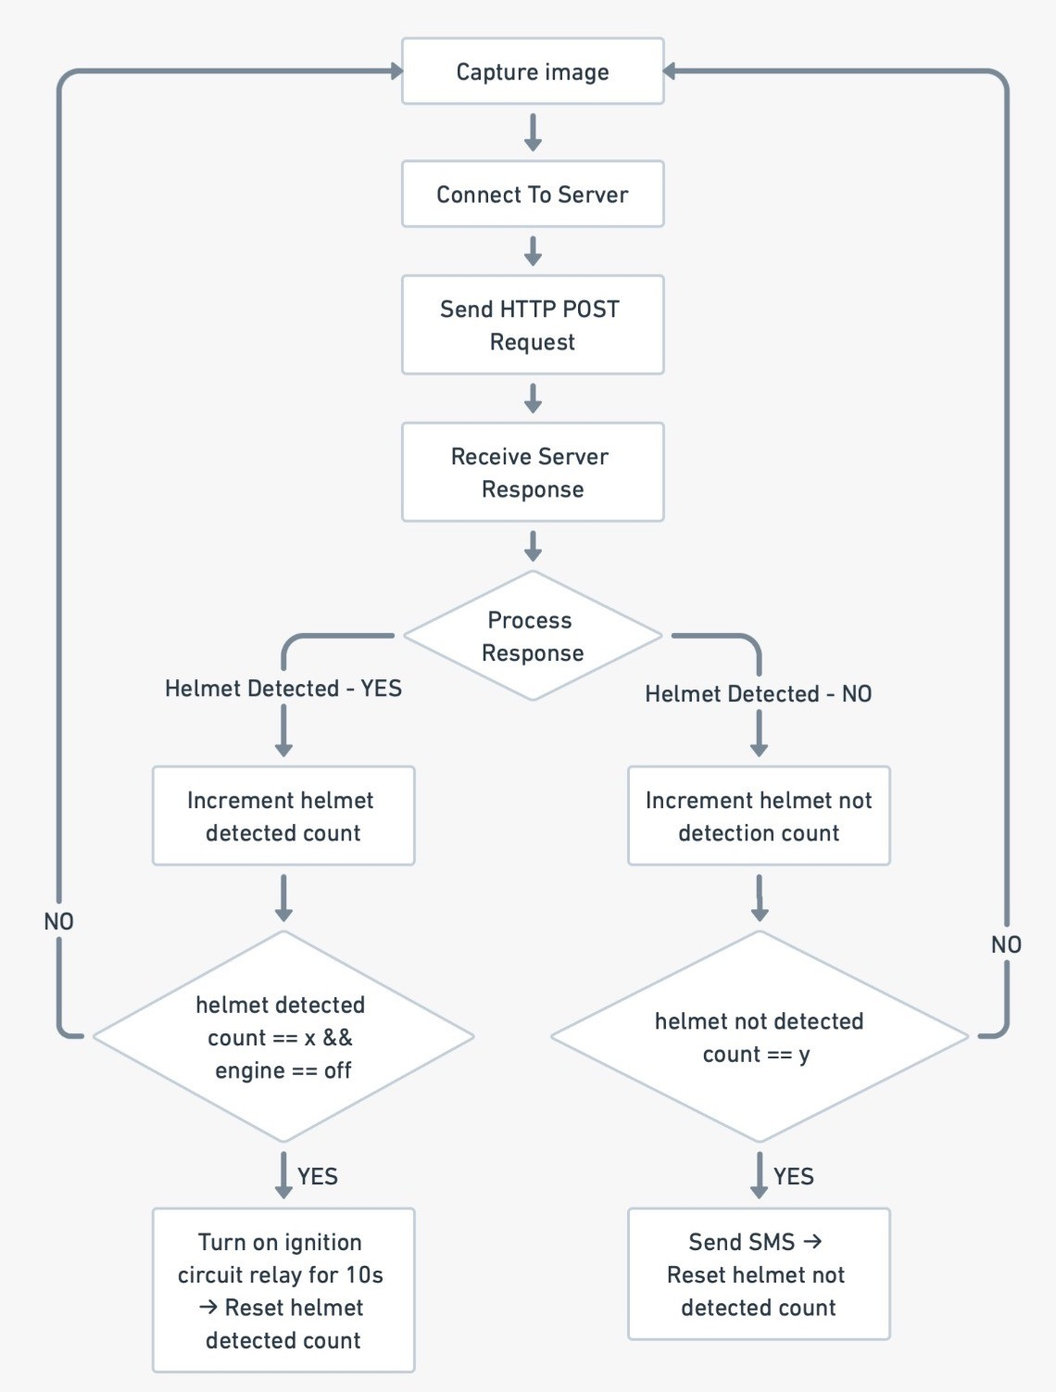Figure 4. Helmet detection and ignition control flowchart

1. OUTCOME

The system designed to enforce helmet usage and improve emergency response in motorcycle accidents was implemented successfully, demonstrating significant advancements in safety features. This section presents the outcomes obtained from the implementation and testing of the proposed system, with particular emphasis on the image acquisition, ignition control circuit, and the integration of cloud services.

1. *Web server testing*

The web server, built with Node.js and Express.js, is tested using the Postman API testing platform. When the server receives a POST request, it analyzes the image for helmet detection using the GCP Vision API. The API endpoint then returns a response indicating whether a helmet was detected, along with an array of all identified labels. This response is displayed in the Postman platform as seen in Figure 5.

Figure 5. API testing using Postman

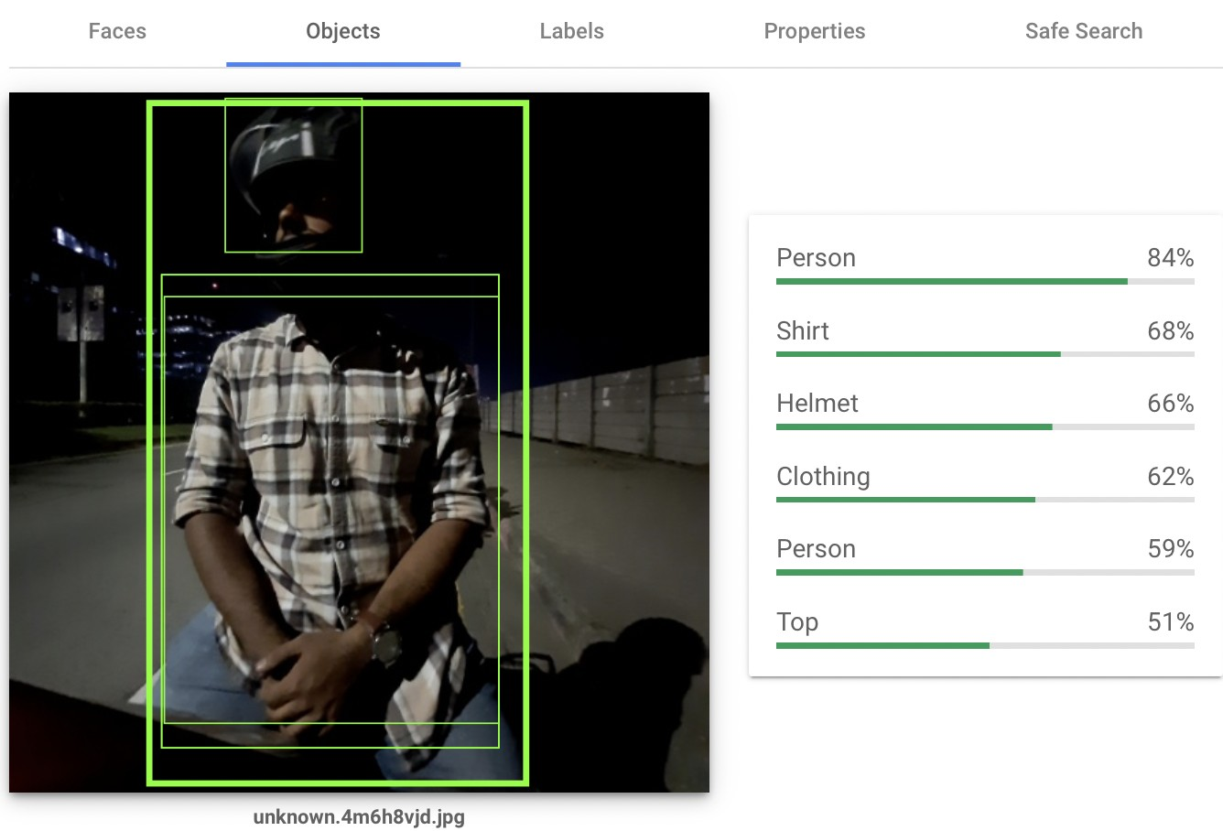

Figure 6. GCP Vision API testing

1. *Hardware testing*

The hardware unit, which includes image acquisition and ignition control, was initially tested in the laboratory using a DC supply, a 12V two-wheeler battery, a multimeter, and other components. After successful testing of the ignition control cir- cuit, it was integrated with the two-wheeler’s ignition system shown in Figure 7. Following this, the image acquisition unit (ESP-32 Cam module) was also integrated and tested. Finally, the emergency SMS algorithm was tested using the Twilio SMS API service as shown in Figure 8.

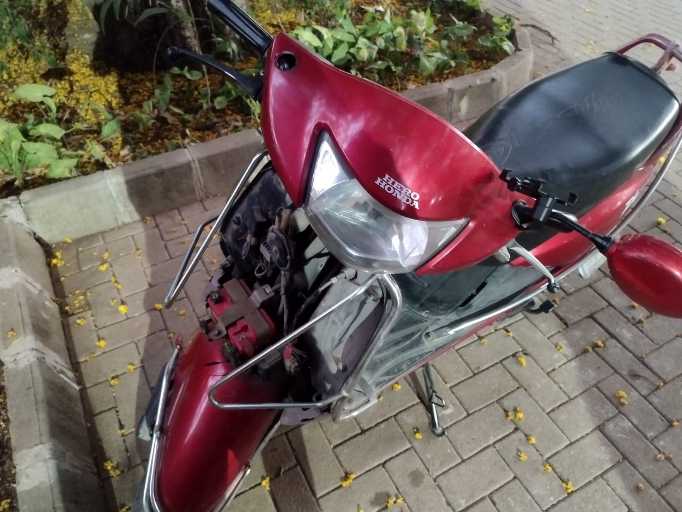

Figure 7. Bike ignition circuit



Figure 8. Emergency SMS alert

1. FUTURE SCOPE

The next iteration of this system aims to significantly enhance its capabilities and functionality through the integra- tion of additional features. The upcoming enhancements are designed to provide a more robust and comprehensive solution for rider safety and traffic management along with a user friendly interface to interact with the system.

1. *Integration of Accident Alert Mechanism*

The system will incorporate an advanced accident alert mechanism. Central to this enhancement will be the addition of a Neo-6M GPS module. This module will provide accurate real-time tracking of the rider’s location, allowing the system to pinpoint the exact position in the event of an accident.

1. *Advanced Sensor Integration*

To improve the accuracy and reliability of accident detec- tion, the system will integrate an MPU-6050 sensor. This sensor measures acceleration and orientation, enabling the system to detect sudden impacts or abnormal movements that could indicate an accident. By processing the sensor data, the system will be able to trigger immediate alerts based on predefined thresholds.

1. *Enhanced Communication Capabilities*

The ESP-32 Cam module will be integrated into the system to facilitate communication and alerting. This module will work in conjunction with a GSM module to send instant alerts to emergency contacts. In the event of an accident, the system will automatically dispatch messages or make calls to predefined emergency numbers, providing critical information about the accident and the rider’s location.

1. *Development of a Comprehensive Web Application*

We plan to develop a comprehensive web application with several key features:

* + **Helmet Usage Monitoring:** Traffic authorities will be equipped with tools to monitor helmet usage in real-time. The system will detect and report violations, ensuring compliance with safety regulations and enabling timely enforcement actions.
  + **Rider Status Tracking for Families:** The web appli- cation will provide families with the capability to track their loved ones’ location and other details like helmet compliance. This feature aims to enhance personal safety and offer peace of mind to family members.
  + **Automated Challan Issuance and Penalty Settlement:** The application will include functionalities for auto- mated challan issuance for traffic violations. It will also streamline the penalty settlement process, making traffic management more efficient and reducing administrative burden.

In summary, the planned upgrades aim to create a more effective and integrated system that improves rider safety, facilitates timely emergency responses, and streamlines traffic management processes. The incorporation of advanced sen- sors, communication technologies, and a user-friendly web application will significantly enhance the overall functionality and impact of the system.

1. CONCLUSION

This initiative helps take a significant step forward in road safety and also helps spread awareness about helmet regula- tions. Through a detailed study of related work done, we have gained valuable insights into the considerations necessary for making this work feasible in the real world. For the next step, our focus can be on refining our system by reducing latency, improving accuracy, and making the hardware as compact as possible to be practical in real life. A web application for users to check rider status, edit account details, etc can also be an addition to the system. If successful, this work can bring about a change in the system and more importantly save lives. Taking inspiration from this work, similar safety systems can be implemented in public transportation, logistics, emergency services, etc. In conclusion, this work is a positive step towards leveraging technology for the betterment of society.

REFERENCES

1. G. S. D. Lakshmi, S. A. Fathima, and J. S. Sree, “Helmet detection using AI,” International Journal of Recent Technology and Engineering, vol. 8, no. 5, pp. 23–29, May 2023.
2. P. Yellamma, N. S. N. S. P. Chandra, P. Sukheshi, P. Shrunith, and

S. S. Teja, “Arduino-based vehicle accident alert system using GPS, GSM and MEMS accelerometer,” Journal of Engineering Research and Applications, vol. 9, no. 4, pp. 102–108, Apr. 2021.

1. S. Shalini, R. Arthi, R. Preetha, and V. P. Lakshmi, “Vehicle ignition control using Raspberry Pi and machine learning,” International Journal of Engineering Trends and Technology, vol. 69, no. 4, pp. 301–306, 2021.
2. S. V. S. V. P. D. Kumar, S. Akashe, and V. Kumar, “Advanced control of switching ignition by smart helmet,” International Journal of Advanced Research in Computer Science and Software Engineering, vol. 8, no. 2, pp. 1–5, Feb. 2018.